Tugas 2

Rekayasa Perangkat Lunak Berbasis Komponen

Nama : Tasya Chandra Icha Pratiwi

NIM : 21120117130059

Kelas : A

Expression Language

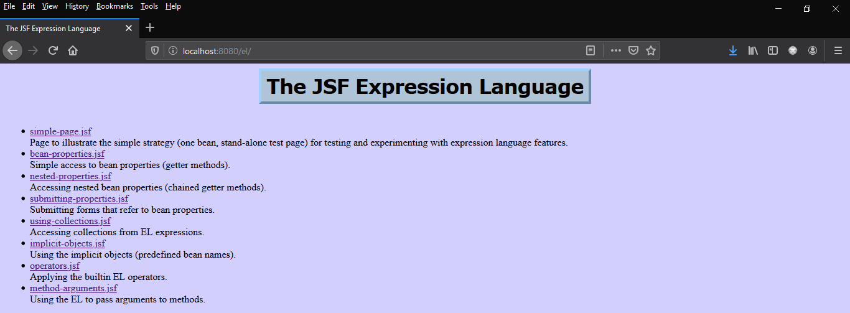

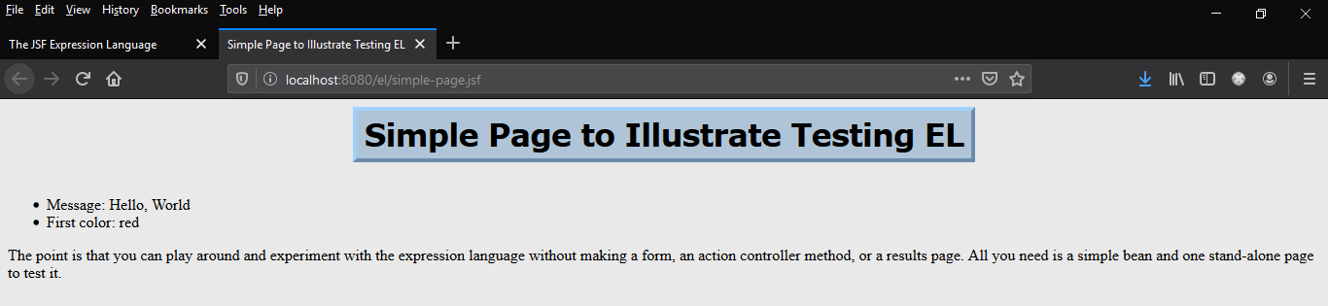

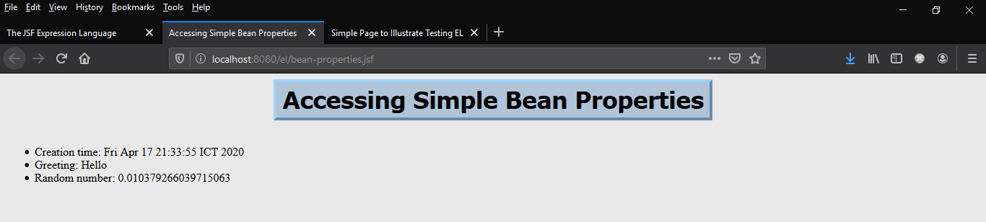

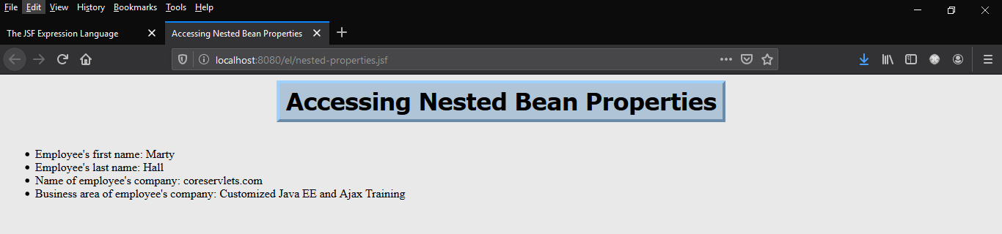

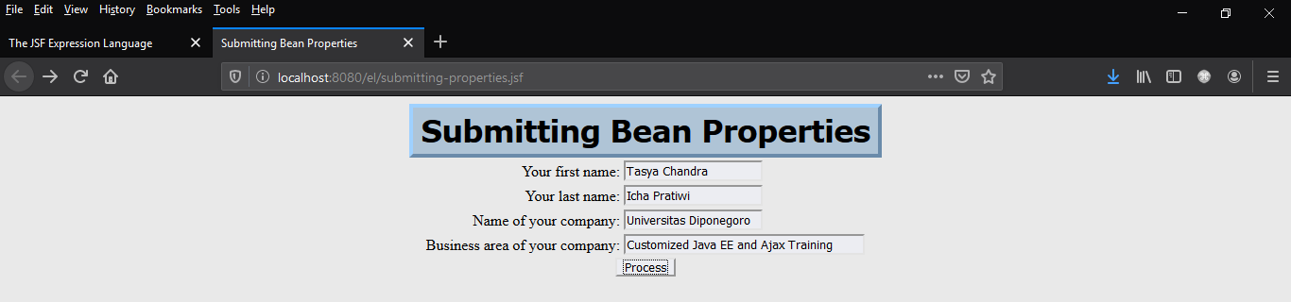

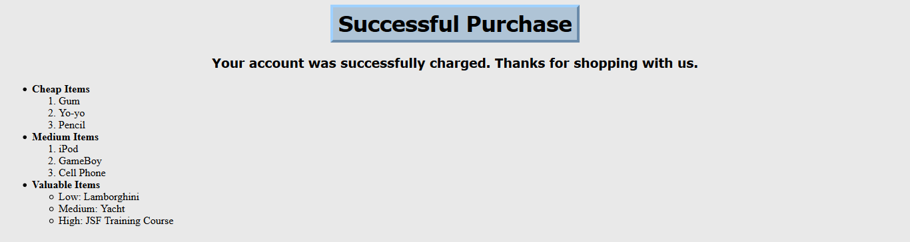

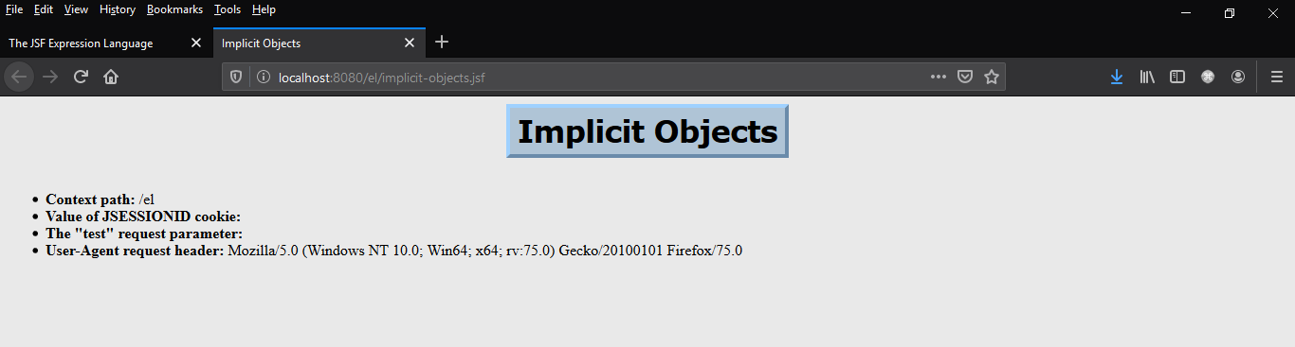

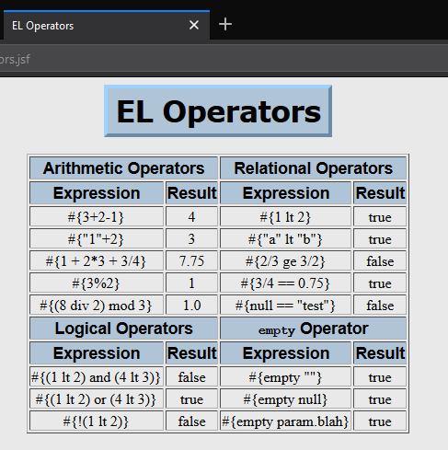

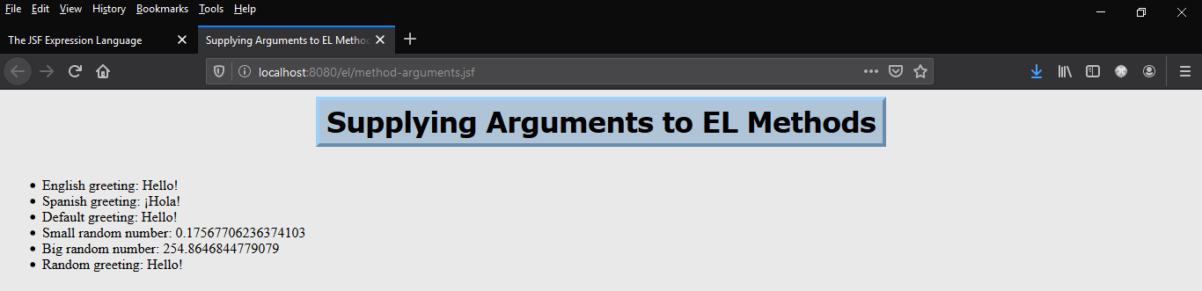

Validation #1

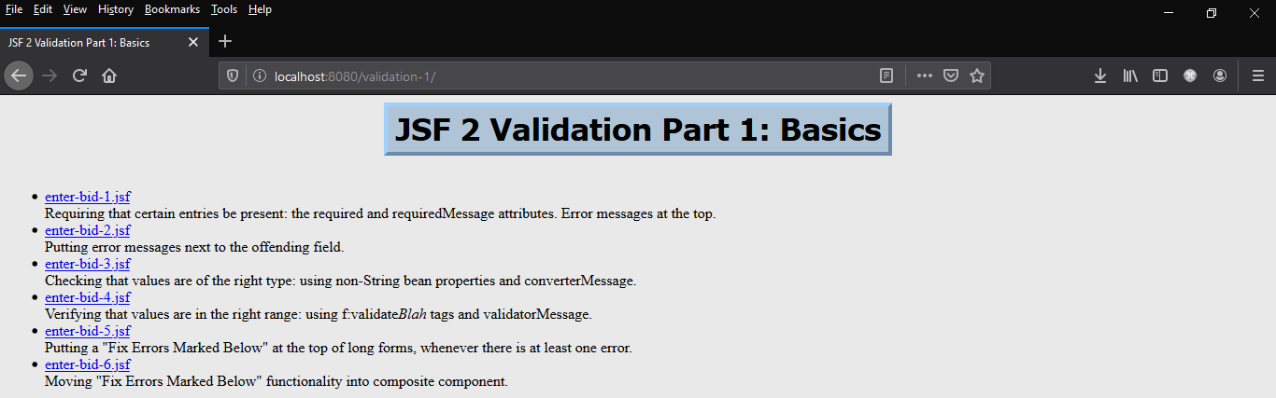

enter-bid-1 (error message at top)

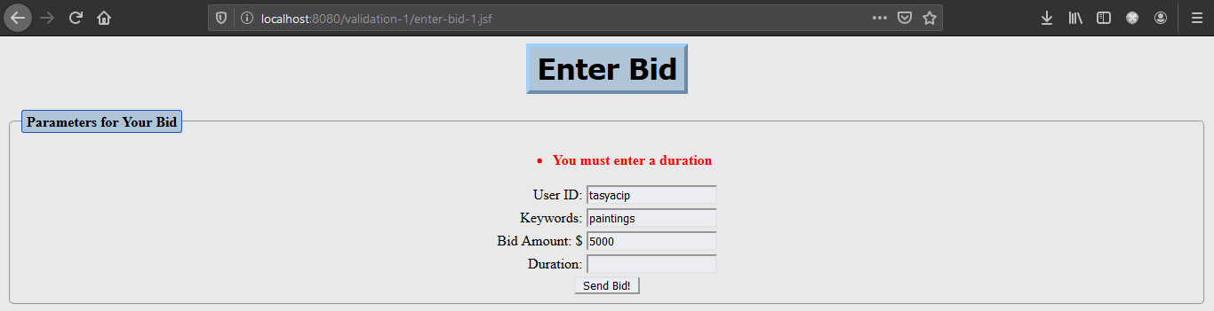

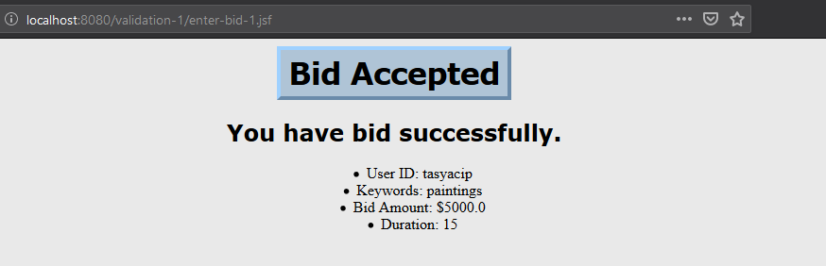

Enter-bid-2 (error message at right)

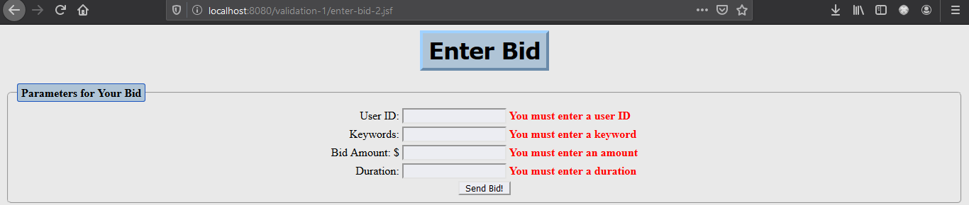

Enter-bid-3 (checking for the right values type)

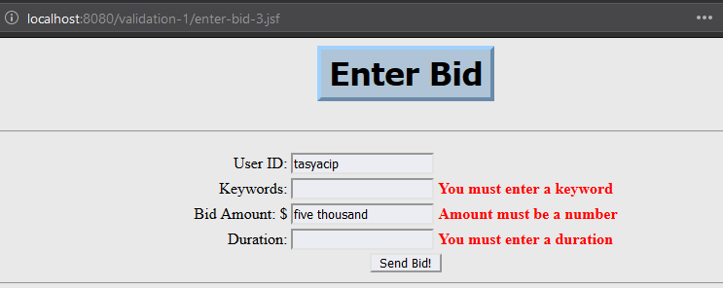

Enter-bid-4 (checking for the right values range)

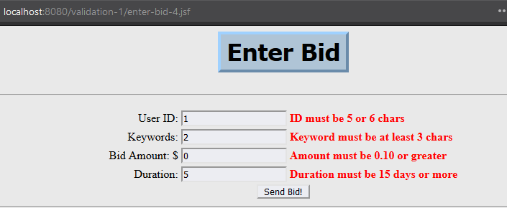

Enter-bid-5 (fix error mark when there is at least 1 error)

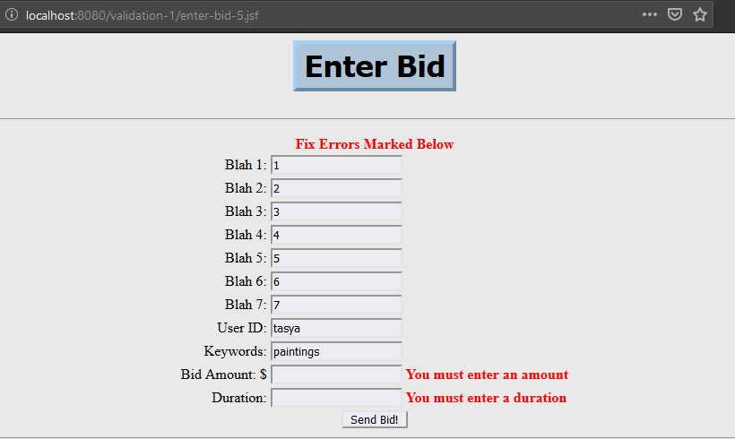

Enter-bid-6

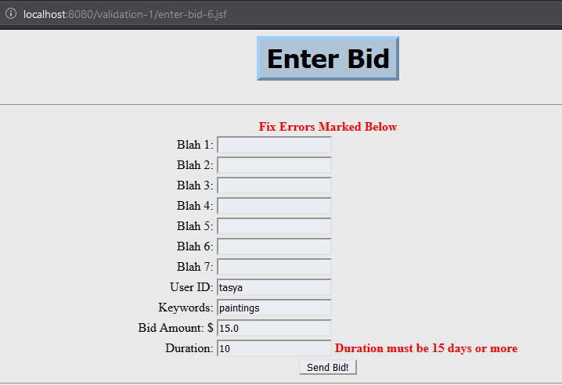

Validation #2

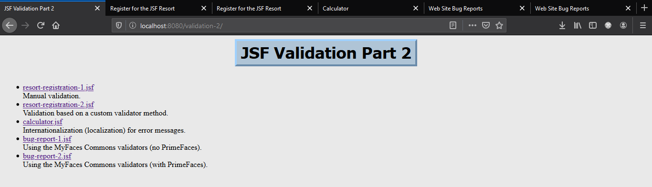

Manual Validation

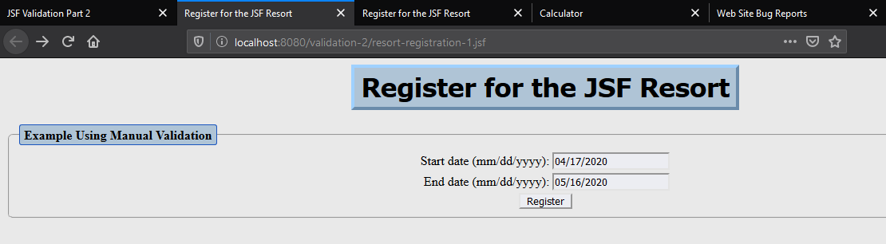

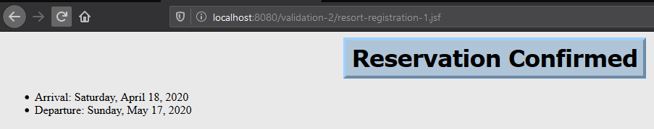

Custom Validation Method

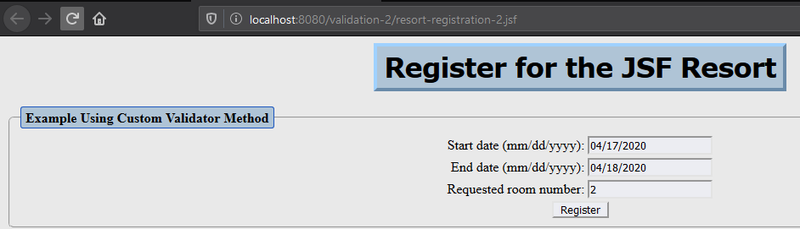

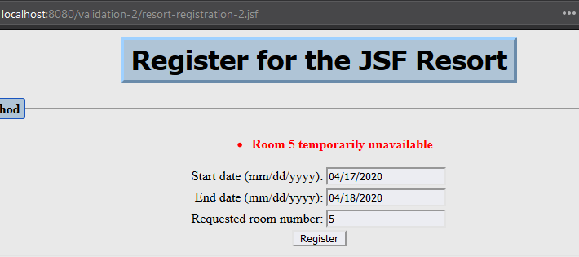

Calculator

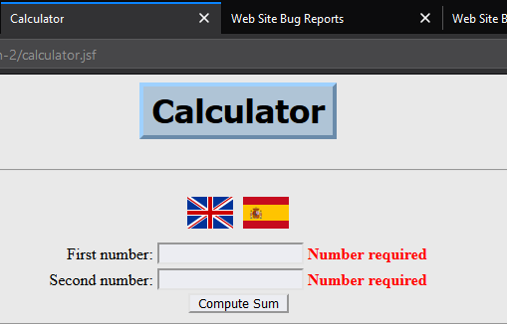

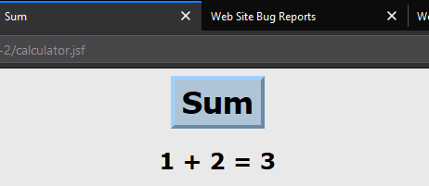

Website Bug Report Withour PrimeFace

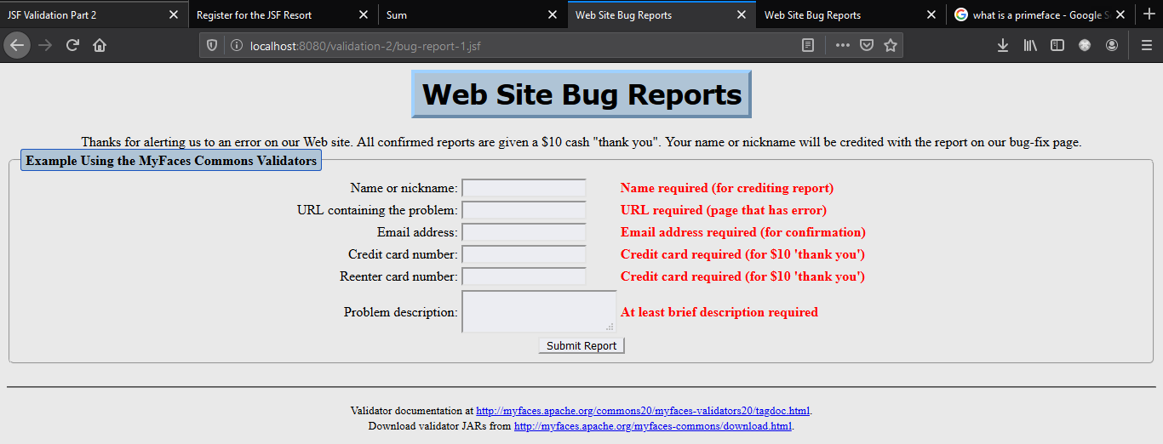

Website Bug Report Withour PrimeFace

